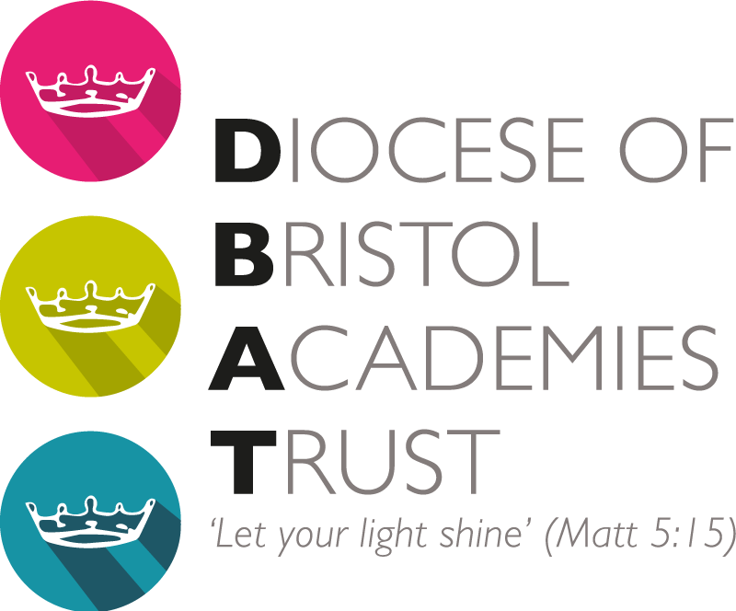

In September 2023, the Deanery received a Special Measures judgement from Ofsted. This led to a Termination Warning Notice being issued to DBAT from the Department for Education (DfE) which advised that they were minded to re-broker the Deanery to another multi-academy trust.

Following on from this, DBAT has been engaged in discussion with the DfE about the next steps for the school. The DfE have now confirmed that the Deanery will be re-brokered to another multi-academy trust. The majority of TWNs do result in this outcome. We are sorry that this is the result, and we remain committed to ensuring the strong progress made in the school over recent months carries on, at pace, as we work with the trust that will take the Deanery into their family of schools.

DBAT Trustees have taken the decision that Kingfisher should transfer with the Deanery, to the new trust, protecting the campus model that the schools work within, and the benefits and opportunities that this brings. The DfE have confirmed their agreement to this.

As a result of the inevitable changes to the financing of the trust as a result, and after a detailed review of how we could continue to support our remaining schools, the Trustees have also reached the decision to start the process to transfer all DBAT schools to other multi-academy trusts and cease the operation of DBAT. This decision has not been taken lightly but has been taken with children at the heart of it. Trustees are united in the view that this decision will allow each of our schools to be in a family of schools where there is greater levels of resource, and capacity, available to support them. The DfE have not yet formally confirmed their agreement of this.

At this stage, a new trust/trusts have not been confirmed and we cannot provide a timetable for the transfer of schools. We anticipate that this will develop at pace throughout the remainder of this academic year, and we will ensure that you are provided with regular updates. The transfer is not expected to result in any changes to your school staff structure.

We remain absolutely committed to ensuring that our schools receive the best support that we can, and working proactively as new partner trusts are confirmed to ensure a smooth transition, and with the maximum benefit for children.

Yours sincerely

Nigel Daniel
DBAT Chair of Trustees

12th January 2023

